**PROJECT**

**REPORT**

**"ONLINE CAB BOOKING SYSTEM"**

**SUBMITTED BY: Supervisor:**

**TANUJ ROHILLA(15564) MRs.KavitaRastogi**

**ROHIT KUMAR(15552)**

**SUNIL KUMAR(15563)**

**INDEX**

1.Problem Statement 4

2.Process Model 6

3.Software Requirement Specification 7

3.1 Introduction 7

3.2 Overall Description 9

3.2.1 Product Functionality 10

3.2.2 Benefits of System 10

3.2.3 Product Characteristics 11

3.2.4 General Constraints 11

3.3 Specific Requirements 12

3.3.1 External Interface Requirements 12

3.3.1.1 User Interface 12

3.3.1.2 Hardware Interface 12

3.3.2 Hardware Requirements 12

3.3.3 Software Requirements 13

3.4 Functional Requirements 14

3.4.1 Administrator Aspect 14

3.4.2 Employee Aspect 14

3.4.3 Client Aspect 14

3.4.4 Analysis 14

3.4.5 Mailing 14

3.5 Security Requirement 15

3.6 Portability Requirement 15

3.7 Reliability Requirement 15

3.8 Usability Requirement 16

3.9 Performance Requirement 16

3.10 Data Flow Diagram 17

3.11 Data Dictionary...................................................................................21

4. Design.........................................................................................................22

4.1 Architectural Design.............................................................................22

4.2 Database Design...................................................................................23

5. Estimation 27

5.1 Function Points 27

5.2 Efforts 29

6.Time Line Chart 30

7.Risk Management 31

8. Testing........................................................................................................35

**1. PROBLEM STATEMENT**

The old cab booking system was suffering from a series of drawbacks. Since whole of the system was to be maintained with hands the process of keeping, maintaining and retrieving the information was very tedious and lengthy. The records were never used to be in a systematic order. there used to be lots of difficulties in associating any particular transaction with a particular context. If any information was to be found it was required to go through the different registers, documents there would never exist anything like report generation. There would always be unnecessary consumption of time while entering records and retrieving records. One more problem was that it was very difficult to find errors while entering the records. Once the records were entered it was very difficult to update these records.

In present, work done in the railway board is performed manually which is a great headache for the department .The reason behind it is that there is lot of information to be maintained and have to be kept in mind while running the business .For this reason we have provided features Present system is partially automated (computerized), actually existing system is quite laborious as one has to enter same information at three different places.

Following points should be well considered-:

Documents and reports that must be provided by the new system: there can also be few reports, which can help management in decision-making and cost controlling, but since these reports do not get required attention, such kind of reports and information were also identified and given required attention.

Details of the information needed for each document and report.

The required frequency and distribution for each document.

Probable sources of information for each document and report.

With the implementation of computerized system, the task of keeping records in an organized manner will be solved. The greatest of all is the retrieval of information, which will be at the click of the mouse. So the proposed system helps in saving the time in different operations and making information flow easy giving valuable reports.

**2. PROCESS MODEL**

Our **CAB BOOKING SYSTEM** uses "**incremental model"** because of the following reasons :

* The model is more flexible - less costly to change scope and requirement.
* As customer can respond to each build so that requirement will meet in next increment.
* It is easier to test and debug.
* Lower initial delivery cost.
* Easier to manage risk because risky pieces are identified and handled during it'd iteration.

**3. SOFTWARE REQUIREMENT SPECIFICATION**

**3.1 INTRODUCTION**

The software to be produced is on "Online cab booking system". Our web application through which customer can view available cab, view profile and book a cab.

In metropolitan cities taxis play an important role in day to day transport facilities where other public transport services are inefficient and unreliable. Countries like India which are still in the development phase which consists of large number of taxis, hiring a taxi by street hailing is the most common method. Even though the taxi service is relatively cheap, but it consists of a lot of problems and is usually inefficient. Due to the randomness of the present taxi hailing, the taxi drivers have to suffer from problems like risks to accidents, wastage of fuel, and traffic congestion. On the other hand the passengers have to wait for a large amount of time before finding a suitable taxi. This problem is also faced by people owning a fleet of vehicles which are applied for public transport. So the proposed system plans on targeting these problems and coming up with a suitable solution. It aims on making hiring of taxis easier for the passengers without an additional cost. It will also provide a solution to the problem that the taxi driver faces where he won’t have to wait to find the passengers reducing the wastage of fuel and all other risks like accidents, pollution, traffic etc.

PURPOSE

The purpose of the system is to automate the process of booking a taxi online by collecting all necessary information of the client and then serve the client, calculating the fare, collecting fare. Client details would save into customer database and this enables things to be simplified and considerably quickened, making the customer to login directly and also update his profile. There would be a company database from which admin can access the cab request and then allocate taxi for that customer. On reaching the destination the fare will be taken from customer online and then a feedback form client has to submit.

Goals

The main goal of the system is to automate the process carried out in the organization with improved performance and realize the vision of online booking. Some of the goals of the system are listed below:

* Manage large number of client details.
* Manage all details of clients who registered and requested for getting the service.
* Maintain the data’s effectively.
* View all the details of the clients and employees.
* Showing available vehicles to book for the client.
* Calculating and showing the fare to client after reaching destination.
* Getting the feedback from the client to facilitate future improvement and ratings to calculate salary of driver

SCOPE

This project traverses a lot of areas ranging from business concept to computing field,and required to perform several researches to be able to achieve the project objectives. The area covers include:

* Cab Booking industry: This includes study on how the cab booking business is being done, process involved and opportunity that exist for improvement.
* PHP Technology used for the development of the application.
* General customers as well as the company’s staff will be able to use the system effectively.
* Web-platform means that the system will be available for access 24/7 except when there is a temporary server issue which is expected to be minimal

Objectives of the Proposed System:

The aim of the proposed system is to address the limitations of the current system. The requirements for the system have been gathered from the defects recorded in the past and also based on the feedback from users of previous metrics tools. Following are the objectives of the proposed system:

* **Reach to geographically scattered drivers.** One of the important objectives of the online booking system is communicate with all the cab drivers’s scattered geographically.
* **Automate the process of booking.** The system will reduce the time and effort of the clients and employees and automate the process of booking.
* **Reduced manpower**. Reduce the manpower needed to perform the booking and serving clients.
* **Cost cutting**. Reduce the cost involved in the booking process.
* **Operational efficiency**. Improve the operational efficiency by improving the quality of the process.

**3.2 OVERALL DESCRIPTION**

Product Perspective

**Existing system function:**

Existing system, which is the traditional system, in which client needs to go the Cab office and book manually, which require lots physical and mental efforts. In traditional system there are many chances of human errors like wrong entry of journey date, journey time and destination as everything is recorded manually in a register by an employee, thereby increasing the chances of a mis-registration. Chances of improper communication are high which may result in delay of service. In traditional cab booking system i.e. existing system the level of sharing the information was very weak, that is when any information was shared by the customer was not recorded in the system but only listened by the service provider which may result in loss of relevant information which ultimately results in the delay of service. In existing system the response time from the service was ordinary because of one-way communication which deteriorates the market and goodwill of the organization. It also consumes unnecessary time and efforts, thereby making it not feasible for customers who do not have time to spare on such bookings while leading their fast lives.

**Product functionality**:

Cab booking System provides the features for booking a car online. It includes severalfunctionalities describes as below:

***1. CabManagement:***

It provides cab booking facility online. Customer can visit the website and check for variouscars. If they are feasible as per requirement, then booking can be done.

***2. CheckingForAvailability:***

Admin can check for the availability of the car. He/she maintains the database of car. If noany car is available it is the responsibility of the Admin to provide alternative options.

***3. Payment system:***

After the ride is over and customer reaches its destination then he will have to make payment via e-wallet online.

BENEFITS OF SYSTEM

As with most real world activities, there are numerous benefits to using a software system taxi booking. The most apparent to this project is the unification of the entire process. This is a far more reasonable storage method than a paper-based file system, where the time of traveling to and physically searching the records for the required information could be a burden. Human error could also be a factor in that mistakes could be made in the filing process which would not occur in a well written database system and mistakes or changes on physical records can be messy to correct. Software systems are also much faster at performing certain tasks than humans, meaning that time can be saved performing processes. This also means that these tasks can be done solely by the system, freeing up those involved to perform more important tasks. In the long term, if methods or minor details concerning booking system, this can be reflected in potentially minor changes to the code of the system, to retrain employees rather than having regarding the new practices.

PRODUCTCHARACTERSTICS

Some of the features are identified for the software. They are listed below:

* **View Available Vehicles:** The admin must able to see all details about the available vehicles without any constraints.
* **Profile:** The client must be available to check the profile anytime.
* **Feedback:** The administrator can able to see the feedback given by each client so that he can take appropriate actions for future improvement.
* **Record maintenance:** The admin also must keep track the statistical reports of daily activities of the online booking.
* **Discount Offer:** The admin can create discount codes and the client can get discount on fares using the codes.

GENERAL CONSTRAINTS

The following sections will introduce the numerous requirements of the system from the point of view of different users and admin and will introduce a number of decisions that have been made regarding implementation.

* **Globalization Support:** The system will be in US English, although the application and their options will be in US English. Hence the application and their options are to be in Unicode format.
* **MAXIMUM LIMIT FOR CLIENT**:The database can accommodate a maximum of 10,000 records of clients
* Customer need to enter only source and destination, after that it is the responsibility of admin to allocate him taxi (there will no involvement of customer in b/w that).
* Clients or employees do not have any rights to edit any data in the system only

Admin has the right to modify and maintain driver record and book taxi for client and compute driver’s salary on the basis rating driver gets from client.

**3.3 SPECIFIC REQUIREMENT**

**1. External Interface Requirements**

**User Interface**

* All the users will see the same page when they enter in this website. This page asksthe users a username and a password.
* After being authenticated by correct username and password, user will be redirect totheir corresponding profile where they can do various activities.
* The user interface will be simple and consistence, using terminology commonlyunderstood by intended users of the system. The system will have simple interface,consistence with standard interface, to eliminate need for user training of infrequentusers.

**Hardware Interface**

* No extra hardware interfaces are needed.
* The system will use the standard hardware and data communication resources.
* This includes, but not limited to, general network connection at the server/hostingsite, network server and network management tools.

**2. Hardware Requirement**

**Server side hardware**

* PC or Laptop
* Hard Disk Processor
* High Speed Processor
* Modem of high internet capacity
* A backup Power Supply UPS (in case of Power Failure)

**Client side hardware**

* Smartphone or PC or Laptop
* Internet Facility

**3. Software Requirement**

Client side:

|  |  |
| --- | --- |
| Web Browser | Internet Explorer 6 or anycompatible browser |
| Operating System | Windows or any equivalent OS |

Server side:

|  |  |
| --- | --- |
| Web Server | IIS 7.5 |
| Framework  C# | .NET 4.0 with |
| Database Server  2008 | MS SQL Server |
| Web Browser | Internet Explorer 6 or any  Compatible browser |
| Operating System | Windows  Server 2007 |

**3.4 FUNCTIONAL REQUIREMENTS:**

**The system should satisfy the following requirements:**

**Administrator Aspect**

* Perform weekly roster of employees
* Print reports annually/monthly/weekly or daily
* Check feedbacks
* Send newsletters
* Manage user portfolio
* Changing the super password.
* manages driver profiles
* computes employee salary on basis of rating

**Employee Aspect**

* Logging into the system.
* To check their rating.
* Maintain daily logs.
* Select availability.
* Check online bookings.
* Payment history

**Client Aspect**

* Make a booking
* Check their booking status
* Fair calculation
* Driver history
* Changing password.
* Resetting of forgotten password.

**Analysis**

* Authenticating users based on username and password.
* Keeping session track of user activity.
* Recording client’s request for booking.
* Checking whether the vehicle is available for booking.
* Keeping history of courses bookings.
* Keeping record of feedbacks received from the clients.

**Mailing**

* Temporary password will be mailed to the user incase the user forgets the password.
* Newsletters should go the clients email addresses.
* The client should get notification email of the booking while confirmed.

**3.5 SECURITY REQUIREMENTS**

* Some of the factors that are identified to protect the software from accidental or malicious access, use, modification, destruction, or disclosure are described below. Specific requirements in this area could include the need to:
* Keep specific log or history data sets
* Assign certain functions to different modules
* Restrict communications between some areas of the program
* Later version of the software will incorporate encryption techniques in the user/license authentication process.
* The software will include an error tracking log that will help the user understand what error occurred when the application crashed along with suggestions on how to prevent the error from occurring again.
* Communication needs to be restricted when the application is validating the user or license. (i.e., using https).

**3.6 PORTABILITY REQUIREMENT**

Some of the attributes of software that relate to the ease of porting the software to other host machines and/or operating systems. This may include:

Apache is used to develop the product .It is easiest to port the software in any environment.

**3.7 RELAIBILITY REQUIREMENTS**

Some of the attributes identified for the reliability is listed below:

All data storage for user variables will be committed to the database at the time of entry.

Data corruption is prevented by applying the possible backup procedures and techniques.

**3.8 USABILITY REQUIREMENTS**

Some of the usability requirements identified for this system are listed below:

* A logical interface is essential to an easy to use system, speeding up common tasks.
* Error prevention is integral to the system and is provided in a number of formats from sanity checks to limiting free-text input.

**3.9 PERFORMANCE REQUIREMENTS**

* Operating System : Microsoft WindowsXP/7/8/10 or Linux
* Minimum internet speed required 40kb/sec for surfing and 500kb/sec for

online transaction of payment.

**3.10 DATA FLOW DIAGRAM**

**1. CONTEXT LEVEL DIAGRAM**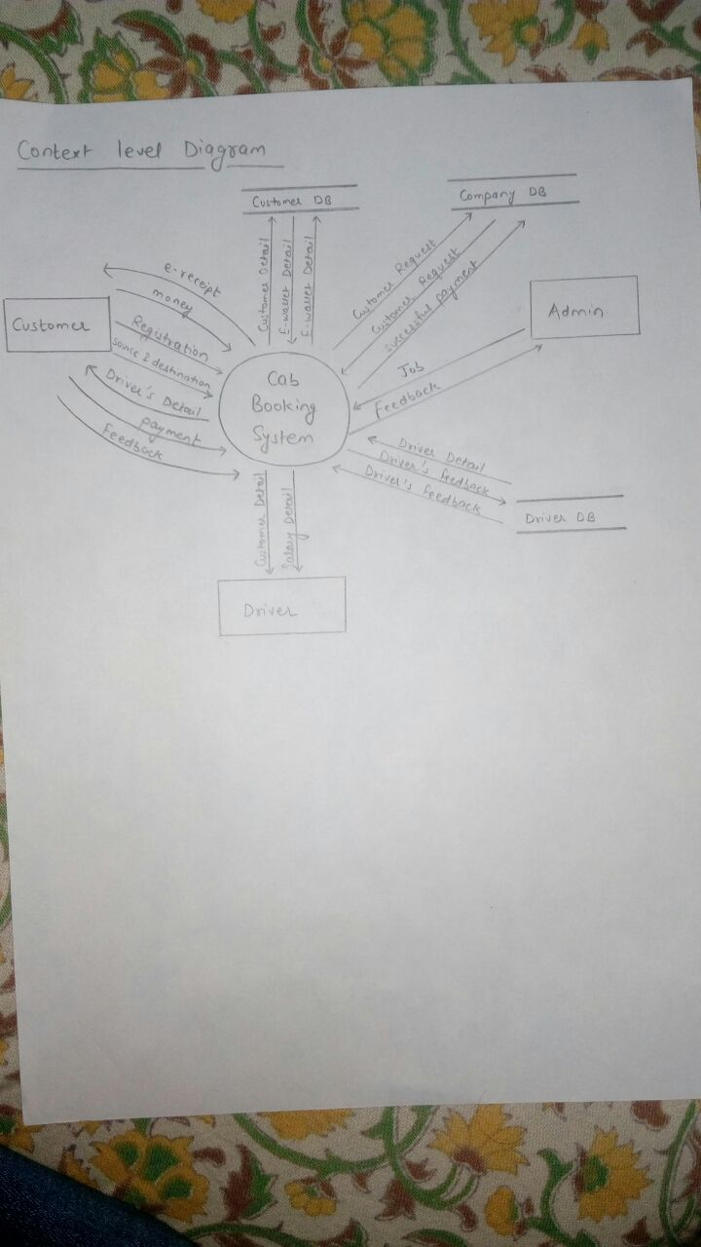

**2. LEVEL 1 DFD**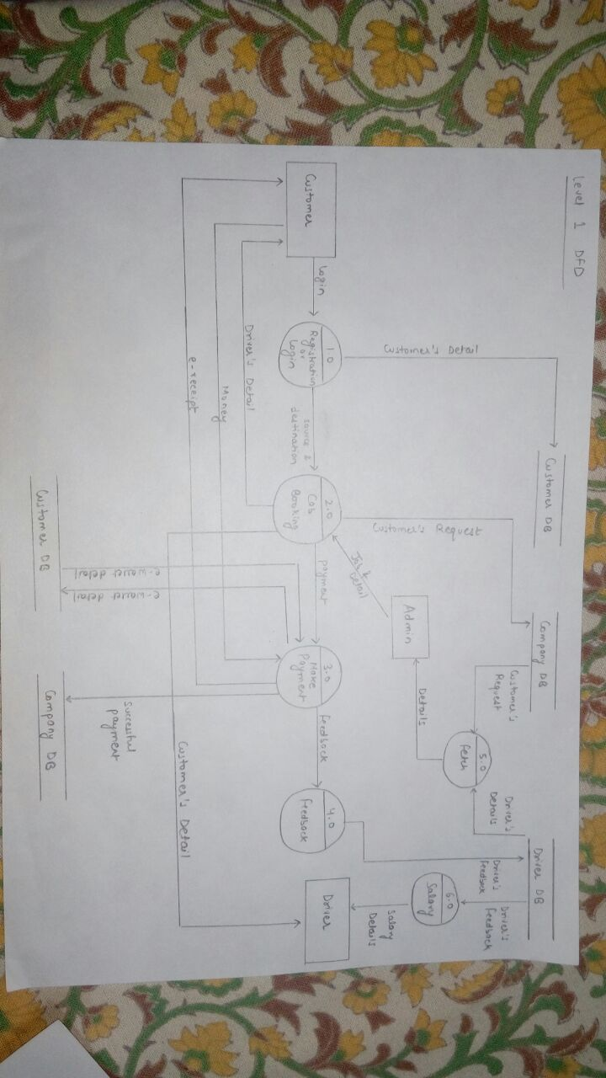

**3. LEVEL 2 DFD**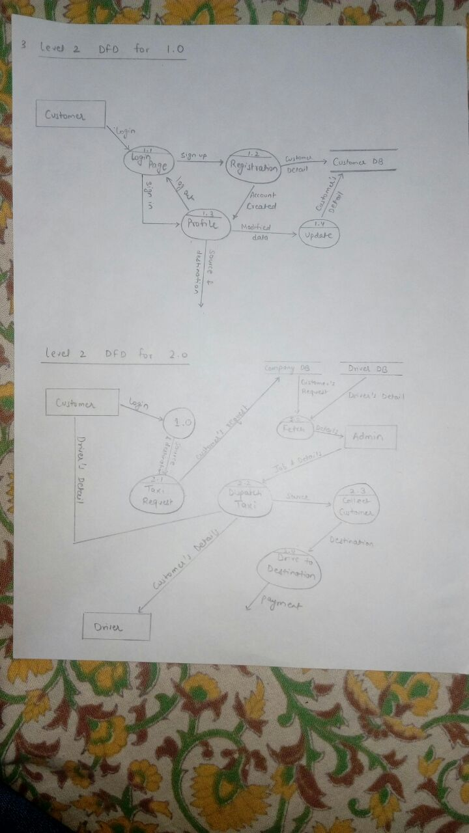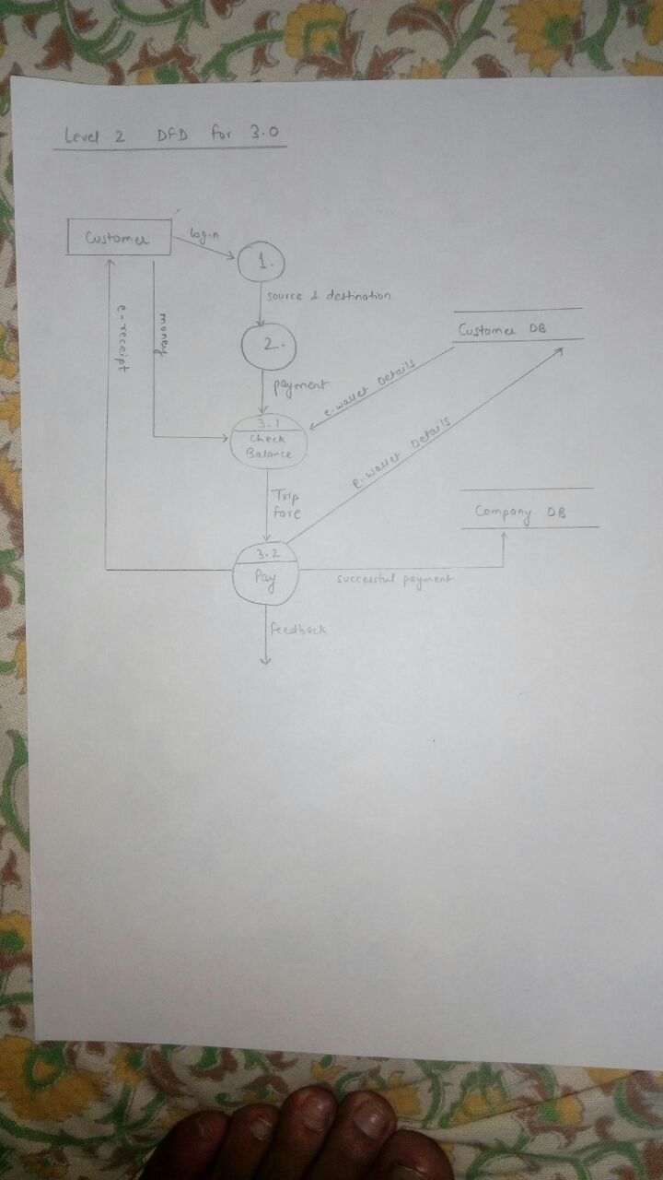

# 3.11 DATA DICTIONARY

Source = (House no.) + [Area/Street no.] + [Town/City] + State + Pin code

Destination = (House no.) + [Area/Street no.] + [Town/City] + State + Pin code

Name = First name + (Middle name) + Last name

Source &Destination = Source + Destination + Customer_id + Name + Phone no. + DOB

Customer’s Request = Source &Destination + (Vehicle Number) + Date

Driver’s Details = Driver_id + Name + Vehicle Number + Phone no. + DOB

Customer’s Details = Customer_id + Name + phone no. + DOB

Details = Customer’s Request + Driver’s Details

**4. DESIGN**

**4.1 Architectural Design**

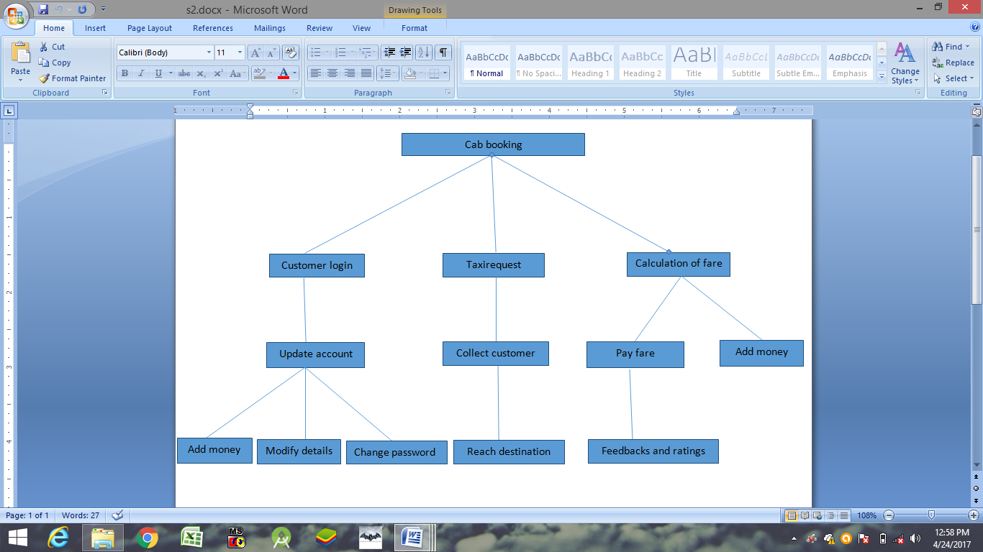

**4.2 Database Design**

**ATTRIBUTES FOR CUSTOMER DATABASE:**

|  |  |  |  |  |
| --- | --- | --- | --- | --- |
| CUSTOMER_ID | NAME | DOB | PASSWORD | PH.NO |

|  |  |  |  |  |  |
| --- | --- | --- | --- | --- | --- |
| SERIAL NUMBER | FIELD NAME | TYPE | SIZE | CONSTRAINT | DESCRIPTION |
| 1. | CUSTOMER_ID | VARCHAR | 30 | PRIMARY KEY | CUSTOMER WILL ENTER HIS/HER EMAIL ID |
| 2. | NAME | VARCHAR | 20 | ------------------- | NAME OF THE  CUSTOMER |
| 3. | DOB | DATE | -------------------- | ------------------- | DATE OF BIRTH OF CUSTOMER |
| 4. | PASSWORD | VARCHAR | 30 | ------------------- | PASSWORD GIVEN BY THE CUSTOMER |
| 5. | PH.NO | NUMBER | 10 | ------------------- | CONATCT NUMBER OF THE CUSTOMER |

**ATTRIBUTES FOR DRIVER DATABASE:**

|  |  |  |  |  |  |
| --- | --- | --- | --- | --- | --- |
| DRIVER_ID | NAME | DOB | PASSWORD | PH.NO | VEHICLE NUMBER |

|  |  |  |  |  |  |
| --- | --- | --- | --- | --- | --- |
| SERIAL NUMBER | FIELD NAME | TYPE | SIZE | CONSTRAINT | DESCRIPTION |
| 1. | DRIVER_ID | VARCHAR | 30 | PRIMARY KEY | DRIVER HAS A UNIQUE ID GENERATED BY ADMIN |
| 2. | NAME | VARCHAR | 20 | ------------------- | NAME OF THE  DRIVER |
| 3. | DOB | DATE | ------------------- | ------------------- | DATE OF BIRTH OF DRIVER |
| 4. | PASSWORD | VARCHAR | 30 | ------------------- | PASSWORD GIVEN BY THE DRIVER |
| 5. | PH.NO | NUMBER | 10 | ------------------- | CONATCT NUMBER OF THE DRIVER |
| 6. | VEHICLE NUMBER | VARCHAR | 15 | FOREIGN KEY | REGISTERED VEHICLE NUMBER OF THE VEHICLE |

**ATTRIBUTES FOR VEHICLE DATABASE:**

|  |  |  |  |
| --- | --- | --- | --- |
| VEHICLE NUMBER | VEHICLE BRAND | VEHICLE BRAND | COST PER KM |

|  |  |  |  |  |  |
| --- | --- | --- | --- | --- | --- |
| SERIAL NUMBER | FIELD NAME | TYPE | SIZE | CONSTRAINT | DESCRIPTION |
| 1. | VEHICLE NUMBER | VARCHAR | 15 | PRIMARY KEY | REGISTERED VEHICLE NUMBER OF THE VEHICLE |
| 2. | VEHICLE BRAND | VARCHAR | 25 | ------------------- | BRAND OF THE VEHICLE |
| 3. | VEHICLE TYPE | VARCHAR | 25 | ------------------- | TYPE OF VEHICLE (3 |
| 4. | COST PER KM | INT | 2 | ------------------ | COST PER KM ASSIGNED TO EVERY VEHICLE |

**ATTRIBUTES FOR BOOKING ENTITY:**

|  |  |  |
| --- | --- | --- |
| DATE | SOURCE | DESTINATION |

|  |  |  |  |  |  |
| --- | --- | --- | --- | --- | --- |
| SERIAL NUMBER | FIELD NAME | TYPE | SIZE | CONSTRAINT | DESCRIPTION |
| 1. | BOOK_ID | VARCHAR | 10 | PRIMARY KEY | UNIQUE BOOK ID FOR EACH TRANSACTION |
| 2. | DATE | DATE | ----------------- | ----------------- | CURRENT DATE |
| 3. | SOURCE | VARCHAR | 20 | ----------------- | SOURCE OF RIDE |
| 4. | DESTINATION | VARCHAR | ------------------- | ----------------- | DESTINATION OF RIDE |

**ATTRIBUTES FOR BILL GENERATION:**

|  |  |  |  |  |
| --- | --- | --- | --- | --- |
| BILL DATE | VEHICLE NUMBER | TAX | TOTAL AMOUNT | JOURNEY TIME |

|  |  |  |  |  |  |
| --- | --- | --- | --- | --- | --- |
| SERIAL NUMBER | FIELD NAME | TYPE | SIZE | CONSTRAINT | DESCRIPTION |
| 1. | BOOK _ID | VARCHAR | 10 | FOREIGN KEY | BILL DETAIL  FROM BOOKING ENTITY |
| 2. | VEHICLE NUMBER | VARCHAR | 15 | FOREIGN KEY | REGISTERED VEHICLE NUMBER OF THE VEHICLE |
| 3. | TAX | LONG | 5 | ------------------- | TAX ON TOTAL  AMOUNT |
| 4. | TOTAL AMOUNT | LONG | 5 | ------------------- | TOTAL FARE |

**5. ESTIMATION**

**5.1 FUNCTION POINT**

VALUE ADJUSTED FACTOR

|  |  |  |
| --- | --- | --- |
| **S.no** | **QUESTION** | **VALUE** |
| 1. | Does the System require reliable backup and recovery? | 5 |
| 2. | Are specialized data communication reqiured to transfer information to or from the application? | 2 |
| 3. | Are there distributed processing functions? | 1 |
| 4. | Is performance critical? | 3 |
| 5. | Will the system run in an existing,heavily utilized operational environment? | 2 |
| 6. | Does the system require online data entry? | 4 |
| 7. | Does the online data entry require the input transaction to be built over multiple screens or operations? | 2 |
| 8. | Are the ILFs updated online? | 3 |
| 9. | Are the input,outputs,files,or inquiries complex? | 2 |
| 10. | Is the internal processing complex? | 1 |
| 11. | Is the code designed to be reusable? | 3 |
| 12. | Are conversion and installation included in design? | 2 |
| 13. | Is the system designed for multiple installations in different organizations? | 3 |
| 14. | Is the application designed to facilitate change and ease of use by the user? | 4 |

(VALUE FROM 0 TO 5 WHERE 0 MEANS NOT IMPORTANT OR APPLICABLE AND 5 MEANS ABSOLUTELY ESSENTIAL)

**Sum of all Value = ∑(fi) = 37**

**VAF = 1.02**

**EXTERNAL INPUTs**

There are 6 External input i.e. **Registration, Source and Destination, Feedback, Payment, Money** and **Job.**

**EXTERNAL OUTPUTs**

There are 5 External output i.e. **E-Recipt,Driver details, Details, Customer Details** and **Salary Details.**

**EXTERNAL QUERRY**

There is 1 External querry i.e. **Customer Request.**

**INTERNAL LOGICAL FILEs**

There are 3 Internal logical files i.e. **Customer database, Company database** and **Driver Database.**

**EXTERNAL INTERFACE FILEs**

There are 5 External interface files i.e. **E-wallet details, Driver's Feedback, Successful payment, Customer details** and **Driver details.**

COMPUTING FUNCTION POINTs

**WEIGHTING FACTOR**

|  |  |  |  |  |  |  |  |
| --- | --- | --- | --- | --- | --- | --- | --- |
| **INFORMATION DOMAIN VALUE** | **COUNT** |  | **SIMPLE** | **AVERAGE** | **COMPLEX** |  | **TOTAL** |
| EXTERNAL INPUTs(EIs) | 6 | x | 3 | 4 | 6 | = | 24 |
| EXTERNALOUTPUTs(EOs) | 5 | x | 4 | 5 | 7 | = | 20 |
| EXTERNAL QUERRY(EQs) | 1 | x | 3 | 4 | 6 | = | 3 |
| INTERNAL LOGICAL FILEs(ILFs) | 3 | x | 7 | 10 | 15 | = | 21 |
| EXTERNAL INTERFACE FILEs(EIFs) | 5 | x | 5 | 7 | 10 | = | 25 |
| **COUNT TOTAL** |  |  |  |  |  | = | 93 |

SO,

**FP(function point)= count total**X**(0.65+0.01** X**∑(fi))**

**= 93** X **(0.65+0.01** X **37)**

**= 93** X **1.02**

**= 94.86 = 95 (approx.)**

# 5.2 EFFORT

The organizational average productivity for systems of this type is **6** FP/pm. Based on a burdened labour rate of **$6000** per month, the cost per FP is approximately **$1000**. Based on the FP estimate and the historical productivity data, the total estimated project cost is **$95,000** and the estimated effort is **16** person-months.

**6. TIMELINE CHART**

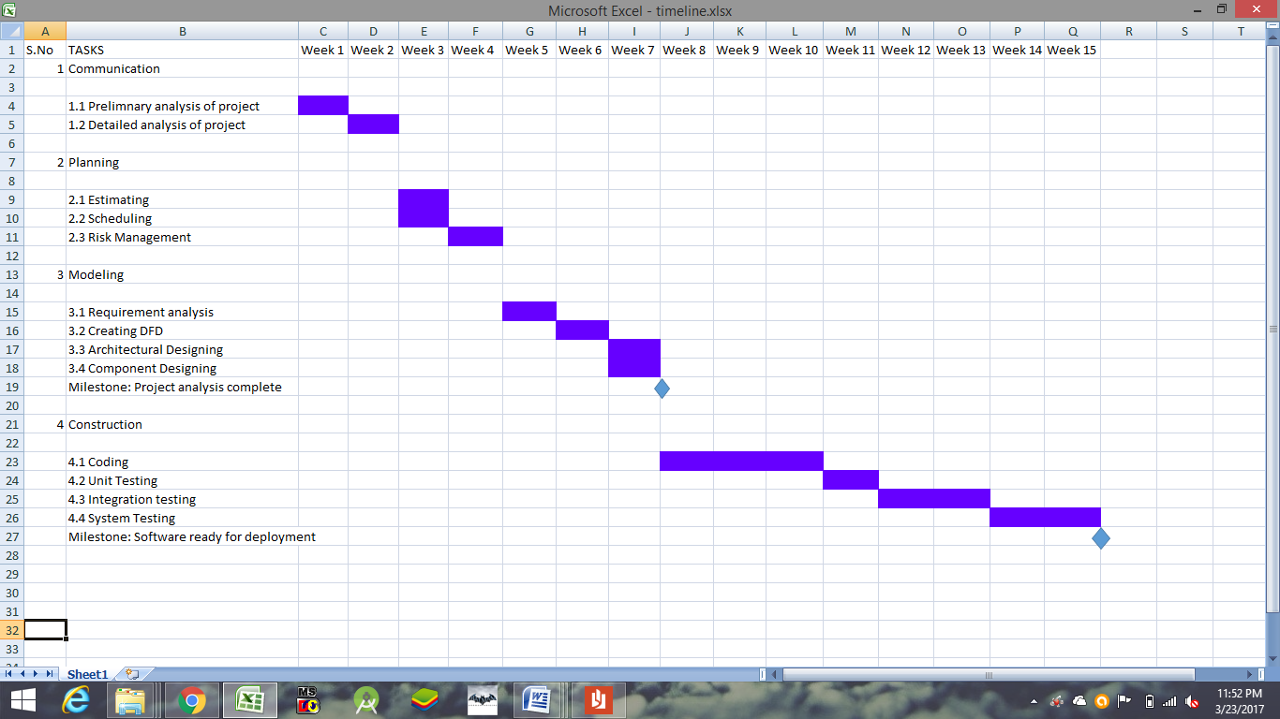

**7. RISK MANAGEMENT**

**RISK 1:*"Unreliable Communication System"***

If communication technologies used (internet via cellular network) do not provide reliable connectivity then Taxi will not get the required information from the Control Center about prospective customer and this will result in low availability of system. High availability and High Reliability of the system may not be achieved.

**RISK 2: *"Accuracy and Reliability of Taxi location Determination"***

If the location determined by taxi subsystem is not reliable and accurate then

1. the taxi may not reach the customer.

2. Customer may be provided with incorrect taxi location.

3. The system may allocate incorrect taxis to a customer.

4. Accurate tracking of taxis for safety will not be achieved.

**RISK 3: *"Security Threats"***

Is there anyone spying on your payment transactions? Is there someone out there trying to sniff your password while you book away to glory? Totally possible! Although, necessary security tools, features softwares have been developed and some technologies also implemented to prevent such security threats, there can exist some loophole somewhere in the system which ultimately paves the way for the attacker.

**RISK 4: *"Funding"***

Fundingis a main risk of our software because we may not get fund from customer for the development of software because there are many similar project that were already developed.

**RISK 5: *" Server Down "***

While using such online bookings and reservation system, if the Server goes down at any time, you have no other option but to halt your booking, which might ultimately prove to be a great disadvantage for you. This is because such instances may cause loss of time, loss of payment, loss of money, loss of opportunity and even make your discontinued/incomplete transactions prone to cyber attacks.

**RISK 6: *"Server crash"***

The server may be crash due to some software problem, low or depleted system resources and the data may be lost which can cause a big problem to the project.

**RISK 7: *"Change is Requirement"***

It can occur any time between the development of product as customer may change the requirement of the product when we are at the end of development phase.

**RISK TABLE**

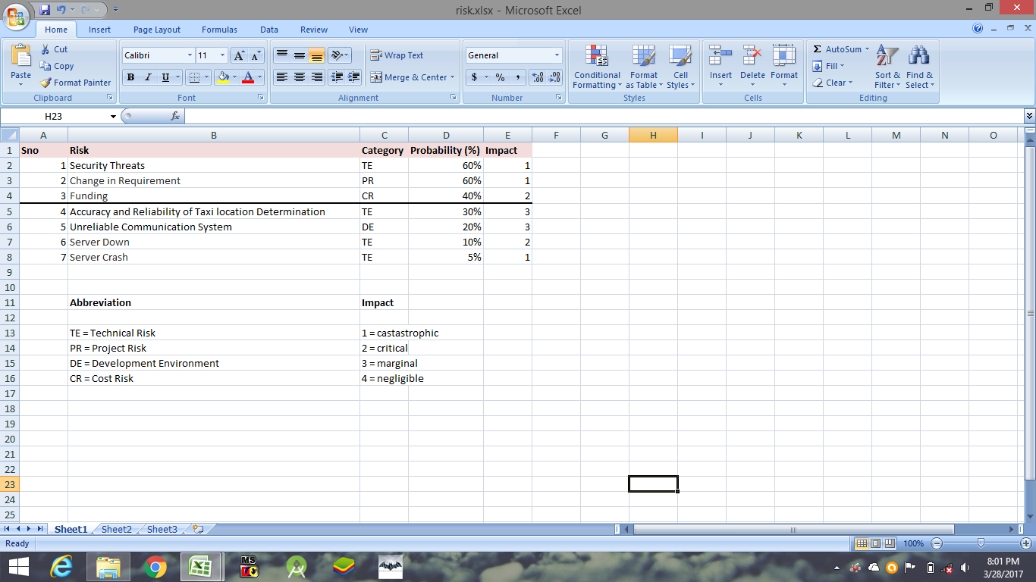

**RMMM Plan**

**1.RISK : Changes in Requirement**

**MITIGATION**

In order to prevent this from happening, meeting (formal and informal ) will be held with the customer on a routine business. This ensures that the product we are producing, and the requirements of the customer are equivalent.

**MONITORING**

The meeting with the customer should ensure that the customer and our organization understand each other and the requirements for the product.

**MANAGEMENT**

Should the development team come to the realization that their idea of the product requirements differs from those of the customer, the customer should be immediately notified and whatever steps necessary to rectify this problem should be taken. Preferably a meeting should be held between the development team and customer to discuss at length this issue.

**2.RISK : Security Threat**

**MITIGATION**

In order to prevent security threats like intentional or acidental hacking, a two step authentication process like sending OTP to the mobile no of the customer and encryption of important info. This will ensure that a person with authenticated mobile no can use our software and data is concealed unless data is decrypted.

**MONITORING**

We can check which user accessing which part of data is accessing and does that user have permission to access that part or not and log it in a file.

**MANAGEMENT**

We can check the log of all ip address recorded to find the hacker and use the backed up data if database is altered.

**8. TESTING**

In our project we have performed **white box testing** because we need to check all logical conditions along with the execution of all loops at all possible inputs and at their boundary also, we have broken down individual units of program into separate module to ensure that each unit is working properly and according to its need then we have determined possible input paths and then calculate cyclomatic complexity.

Pseudo Code

while(1) 1.

{

2.

Enter login id and Password

3. 4.

if(login id = valid && password = valid)

{

break;

}

}

while(1) 5.

{

6.

Enter source and destination

7.

if(cab is available)

{ 8.

book cab

break;

}

else

{ 9.

cab not available

}

}

while(1) 10.

{ 11.

if(available balance in wallet >= fare_amount)

{

update balance

fill feedback 12.

break;

}

else

{

insufficient balance 13.

add amount

}

}

Flow Graph

Cyclomatic Complexity

Cyclomatic complexity is calculated as:

**Cyclomatic Complexity = e - v + 2**

**where,**

**e = number of edges**

**v = number of vertices**

In our module , e=16 v=13

Therefore,

Cyclomatic Complexity = 16 - 13 + 2

= 5

*Therefore cyclomatic complexity will be 5*.

Independent Path

Path 1 1,2,3,4,5,6,7,8,10,11,12

Path 2 1,2,3,1,2,3,4,5,6,7,8,10,11,12

Path 3 1,2,3,4,1,2,3,4,5,6,7,8,10,11,12

Path 4 1,2,3,4,5,6,7,9,5,6,7,8,10,11,12

Path 5 1,2,3,4,5,6,7,8,10,11,13,10,11,12